

FE Fee Waiver Application – student access guide

- Getting ready: Please make sure that you have relevant proof of benefits available. This will have to be uploaded to your FE Part Time Fee Waiver - Student Funding Application form. Unless this confirmation is uploaded, your application for funding will be rejected.

- Go to Log in via www.studentjourney.uhi.ac.uk/urd/sits.urd/run/siw_lgn

- Select Students & Staff Login
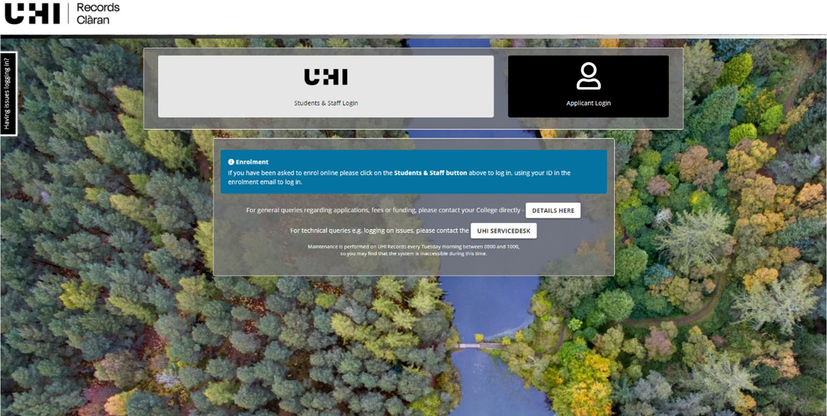

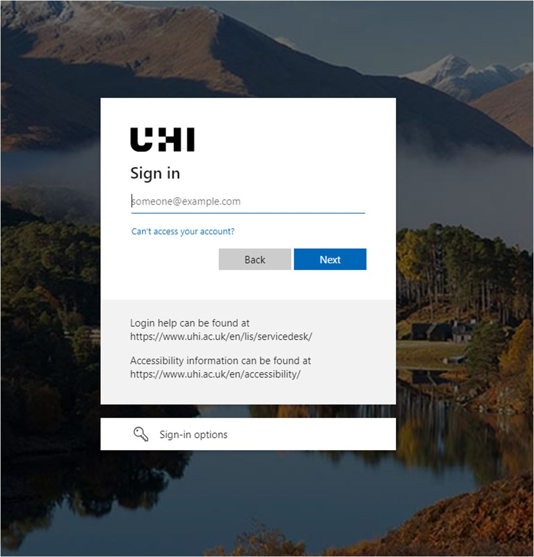
- Sign in
If signing in from home, you may be asked to set the multifactor authentication, where the verification text message or code is sent to the MFA app.
If you need assistance to set this up, please contact UHI Service Desk https://www.uhi.ac.uk/en/lis/servicedesk/

- Select FE Part Time Fee Waiver – Student, on the bottom right hand side corner of funding page.

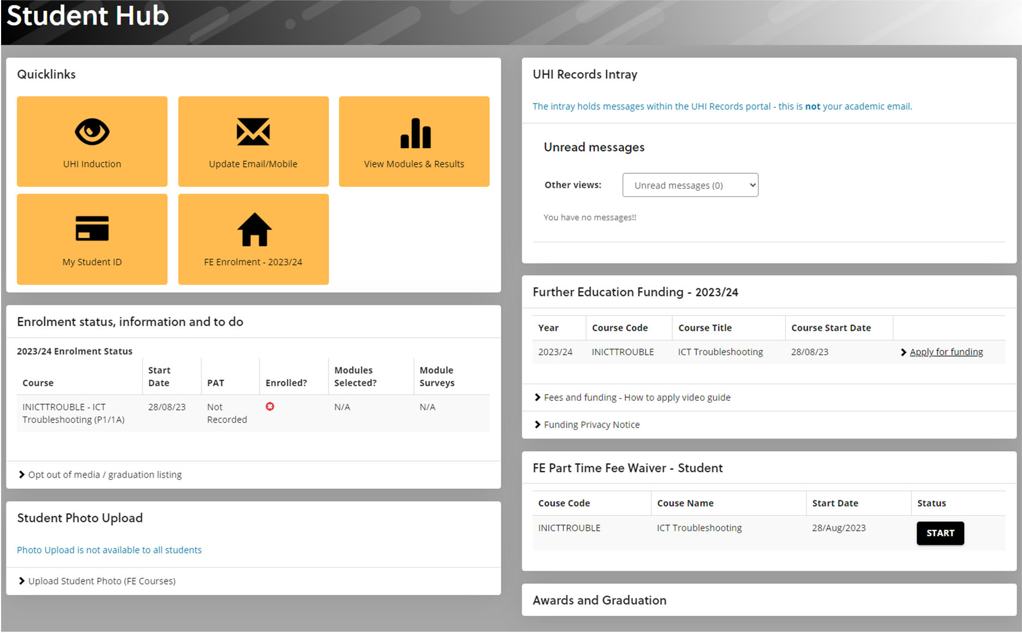

If you need help completing your funding application, please contact the Student Services Team on Student.Services.Moray@uhi.ac.uk or call 01343 576354 or 576265 who will be happy to help you.

